

CSA0506-Database Management Systems

CO2 AT-5

Analytical Problem Solving (High)

Ashmi P S
192571004
1.Applying Relational Algebra Operations on Employee and Department Relations
AIM
To apply relational algebra operations such as Selection (σ), Projection (π), Union (∪), Set Difference (-), Cartesian Product (×), and Join (⋈) on Employee and Department relations to retrieve required records.
DESCRIPTION
Relational Algebra is a procedural query language used to perform operations on relations (tables) in a database. It helps to retrieve required data by applying different operations.
The basic relational algebra operations include:
- Selection (σ): Selects rows that satisfy a given condition.
- Projection (π): Selects specific columns from a relation.
- Union (∪): Combines tuples from two compatible relations.
- Set Difference (-): Returns tuples present in one relation but not in another.
- Cartesian Product (×): Combines every tuple of one relation with every tuple of another relation.
- Join (⋈): Combines related tuples from two relations based on a common attribute.

Step 1: Create Employee Relation
CREATE TABLE Employee(
Emp_ID INT PRIMARY KEY,
Emp_Name VARCHAR(50),
Dept_ID VARCHAR(10),
Salary INT
);
Step 2: Insert Employee Records
INSERT INTO Employee VALUES
(101,'Arun','D1',50000),
(102,'Bala','D2',60000),
(103,'Kiran','D1',55000);
Step 3: Create Department Relation
CREATE TABLE Department(
Dept_ID VARCHAR(10) PRIMARY KEY,
Dept_Name VARCHAR(50)
);
Step 4: Insert Department Records
INSERT INTO Department VALUES
('D1','IT'),
('D2','HR'),
('D3','Finance');
Step 5: Apply Relational Algebra Operations
1. Selection Operation (σ)
Query: Retrieve employees whose salary is greater than 55000.
Relational Algebra:
$${\text{σ}}_{\text{Salary}\text{>55000}}\left(\text{Employee}\right)$$
SQL:
SELECT *
FROM Employee
WHERE Salary > 55000;
OUTPUT
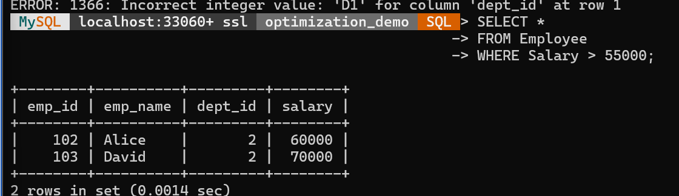
2. Projection Operation (π)
Query: Display only employee names.
Relational Algebra:
$${\text{π}}_{\text{Emp}_\text{Name}}\left(\text{Employee}\right)$$
SQL:
SELECT Emp_Name
FROM Employee;
OUTPUT
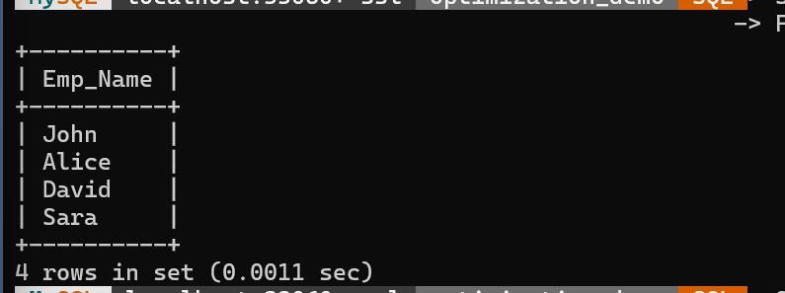
3. Union Operation (∪)
Query: Combine employee names from two relations.
Relational Algebra:
$$\text{Employee}\text{1∪}\text{Employee}\text{2}$$

SQL:
SELECT Emp_Name
FROM Employee1

UNION

SELECT Emp_Name
FROM Employee2;
OUTPUT
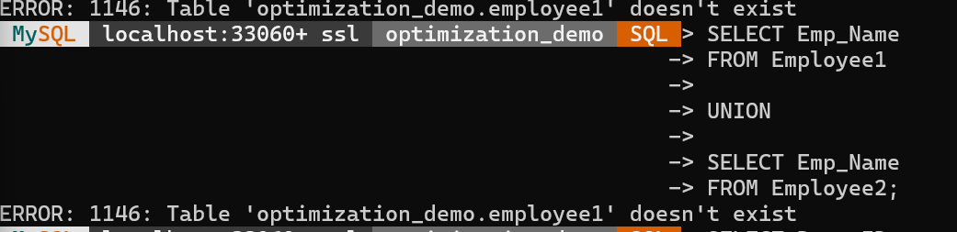4. Set Difference Operation (-)
Query: Find departments that do not have employees.
Relational Algebra:
$${\text{π}}_{\text{Dept}_\text{ID}}\left(\text{Department}\right)\text{−}{\text{π}}_{\text{Dept}_\text{ID}}\left(\text{Employee}\right)$$
SQL:
SELECT Dept_ID
FROM Department

WHERE Dept_ID NOT IN
(SELECT Dept_ID FROM Employee);
OUTPUT
Dept_ID
D3

5. Cartesian Product Operation (×)
Query: Combine all Employee and Department records.
Relational Algebra:
$$\text{Employee}\text{×}\text{Department}$$
SQL:
SELECT *
FROM Employee, Department;
OUTPUT
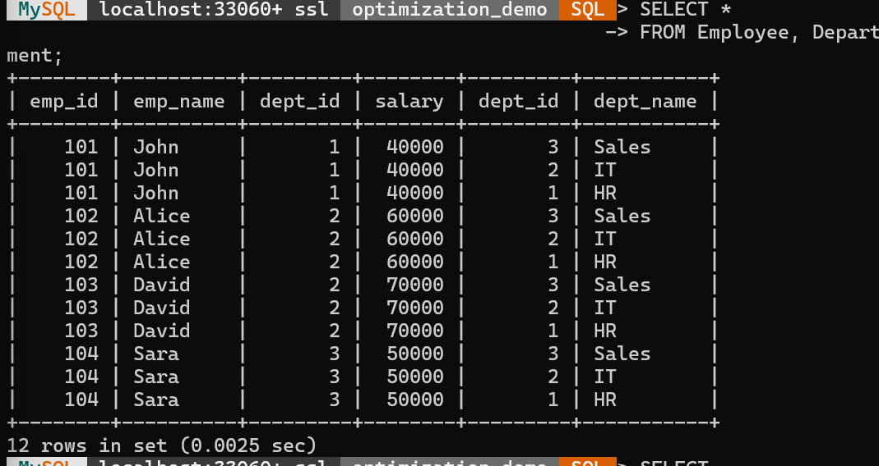6. Join Operation (⋈)
Query: Display employee details with department names.
Relational Algebra:
$$\text{Employee}\text{⋈}\text{Department}$$

SQL:
SELECT
E.Emp_ID,
E.Emp_Name,
D.Dept_Name,
E.Salary

FROM Employee E

JOIN Department D

ON E.Dept_ID = D.Dept_ID;
OUTPUT
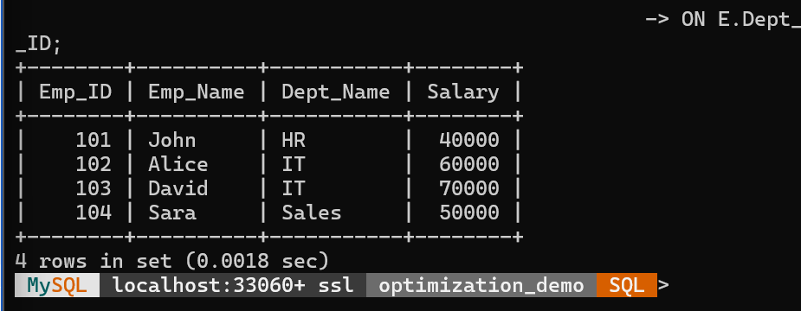

RESULT
Thus, the relational algebra operations Selection (σ), Projection (π), Union (∪), Difference (-), Cartesian Product (×), and Join (⋈) were successfully applied on Employee and Department relations to retrieve the required records.

2.Creation of STUDENT and DEPARTMENT Tables Using SQL DDL Statements with Constraints
AIM
To create STUDENT(SID, Name, DOB, DeptID) and DEPARTMENT(DeptID, DeptName) tables using SQL DDL commands with appropriate constraints like PRIMARY KEY, FOREIGN KEY, NOT NULL, UNIQUE and CHECK.
DESCRIPTION
DDL (Data Definition Language) commands are used to define and modify the structure of database objects like tables.
Constraints are used to maintain data accuracy and integrity.
- PRIMARY KEY: Uniquely identifies each record in a table.
- FOREIGN KEY: Establishes a relationship between two tables.
- NOT NULL: Prevents empty values.
- UNIQUE: Ensures all values are different.
- CHECK: Restricts values based on a condition.

Step 1: Create Database
CREATE DATABASE Student_DB;

USE Student_DB;
Step 2: Create DEPARTMENT Table
CREATE TABLE DEPARTMENT(
DeptID INT PRIMARY KEY,
DeptName VARCHAR(50) NOT NULL UNIQUE
);
Step 3: Create STUDENT Table
CREATE TABLE STUDENT(
SID INT PRIMARY KEY,
Name VARCHAR(50) NOT NULL,
DOB DATE NOT NULL,
DeptID INT,
FOREIGN KEY(DeptID) REFERENCES DEPARTMENT(DeptID)
);
Step 4: Insert Sample Records
Department Table
INSERT INTO DEPARTMENT VALUES
(1,'Computer Science'),
(2,'Information Technology'),
(3,'Electronics');
Student Table
INSERT INTO STUDENT VALUES
(101,'Arun','2005-05-10',1),
(102,'Bala','2004-08-15',2),
(103,'Kiran','2005-01-20',1);
OUTPUT
DEPARTMENT
SELECT * FROM DEPARTMENT;
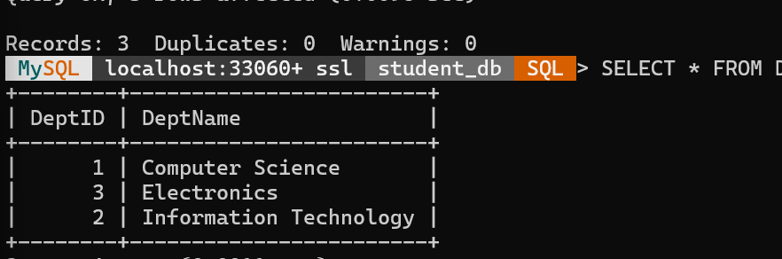
STUDENT
SELECT * FROM STUDENT;
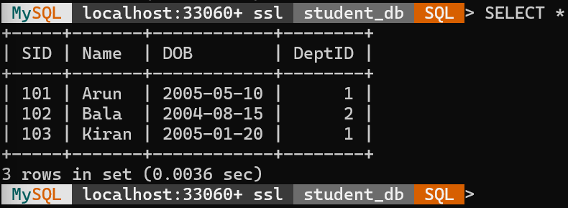
RESULT
Thus, the STUDENT and DEPARTMENT tables were successfully created using SQL DDL statements with appropriate constraints to maintain data integrity.

3.Applying GROUP BY, HAVING and Aggregate Functions on Sales Dataset
AIM
To formulate SQL queries using GROUP BY, HAVING and aggregate functions such as COUNT(), SUM(), AVG(), MAX(), and MIN() on a Sales dataset to retrieve summarized information.
DESCRIPTION
Aggregate functions are used to perform calculations on multiple rows and return a single value.
- COUNT(): Counts the number of records.
- SUM(): Calculates the total value.
- AVG(): Finds the average value.
- MAX(): Finds the maximum value.
- MIN(): Finds the minimum value.
GROUP BY is used to group records based on a specific column.
HAVING is used to filter grouped records based on aggregate conditions.
Step 1: Create Database
CREATE DATABASE sales_db;

USE sales_db;
Step 2: Create Sales Table
CREATE TABLE Sales(
Sale_ID INT PRIMARY KEY,
Product_Name VARCHAR(50),
Category VARCHAR(50),
Quantity INT,
Amount INT
);
Step 3: Insert Records
INSERT INTO Sales VALUES
(101,'Laptop','Electronics',2,80000),
(102,'Mobile','Electronics',5,50000),
(103,'Chair','Furniture',10,30000),
(104,'Table','Furniture',5,25000),
(105,'Printer','Electronics',3,15000),
(106,'Sofa','Furniture',2,40000);
Step 4: Apply Aggregate Functions
1. COUNT() – Count Total Number of Sales Records
SELECT COUNT(*) AS Total_Sales
FROM Sales;

OUTPUT
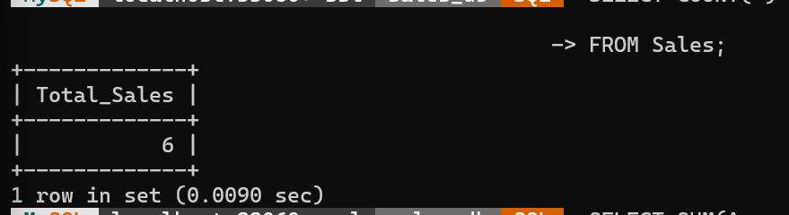
2. SUM() – Calculate Total Sales Amount
SELECT SUM(Amount) AS Total_Amount
FROM Sales;
OUTPUT
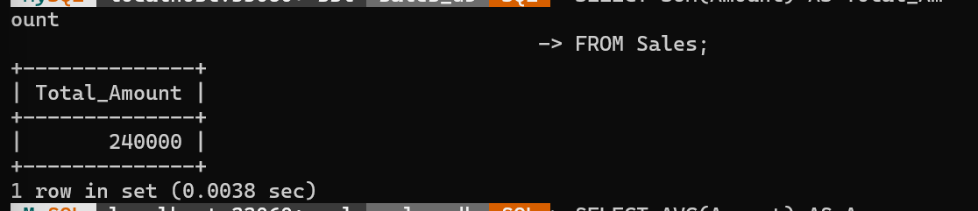
3. AVG() – Find Average Sales Amount
SELECT AVG(Amount) AS Average_Amount
FROM Sales;
OUTPUT
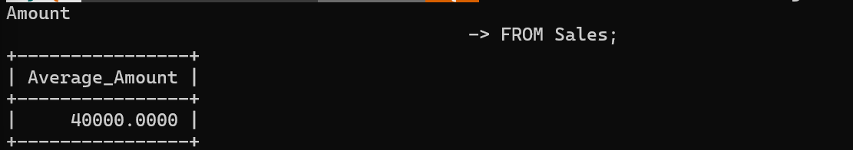
4. MAX() – Find Highest Sales Amount
SELECT MAX(Amount) AS Maximum_Amount
FROM Sales;
OUTPUT
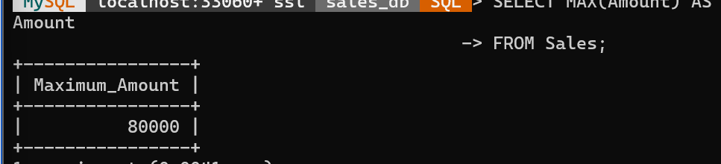
5. MIN() – Find Lowest Sales Amount
SELECT MIN(Amount) AS Minimum_Amount
FROM Sales;
OUTPUT
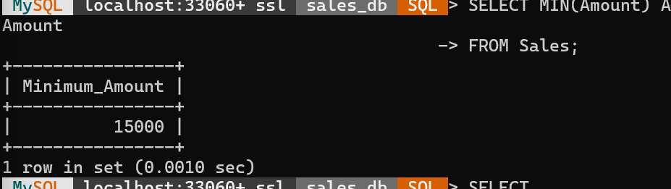
Step 5: GROUP BY Operation
Find total sales amount for each category
SELECT
Category,
SUM(Amount) AS Total_Sales

FROM Sales

GROUP BY Category;

OUTPUT
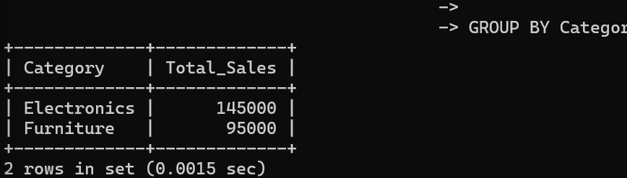
Step 6: HAVING Clause
Display categories having total sales greater than 100000
SELECT
Category,
SUM(Amount) AS Total_Sales

FROM Sales

GROUP BY Category

HAVING SUM(Amount) > 100000;
OUTPUT
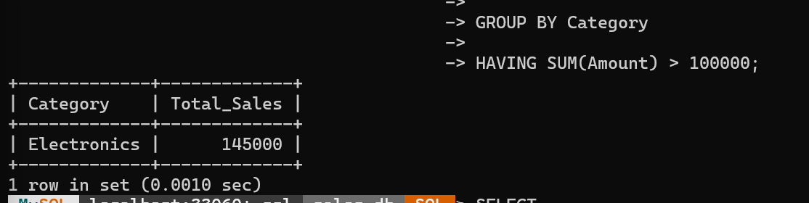
Step 7: GROUP BY with COUNT()
Count number of products in each category
SELECT
Category,
COUNT(*) AS Product_Count

FROM Sales

GROUP BY Category;
OUTPUT
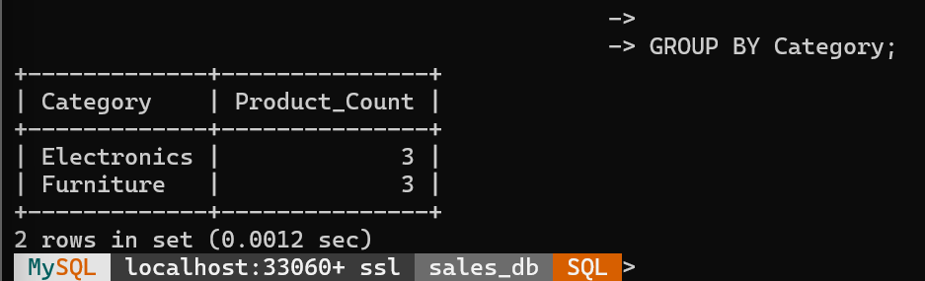
RESULT
Thus, SQL queries using GROUP BY, HAVING, and aggregate functions (COUNT, SUM, AVG, MAX, MIN) were successfully executed on the Sales dataset to retrieve summarized and grouped information.

4.Finding Employees Earning More Than the Average Salary of Their Own Department Using Correlated Sub-query
AIM
To write and execute a correlated sub-query to find employees whose salary is greater than the average salary of their respective department.

DESCRIPTION
A correlated sub-query is a sub-query that depends on the outer query for its execution.
The inner query is executed once for each row of the outer query.
In this experiment, the employee's salary is compared with the average salary of their own department to identify employees earning above the department average.
Step 1: Create Database
CREATE DATABASE company_db;

USE company_db;
Step 2: Create Employee Table
CREATE TABLE Employee(
Emp_ID INT PRIMARY KEY,
Emp_Name VARCHAR(50),
Department VARCHAR(50),
Salary INT
);
Step 3: Insert Records
INSERT INTO Employee VALUES
(101,'Arun','IT',60000),
(102,'Bala','IT',40000),
(103,'Kavi','HR',50000),
(104,'Ravi','HR',30000),
(105,'Mani','Finance',70000),
(106,'Siva','Finance',50000);
Step 4: Apply Correlated Sub-query
Find employees earning more than the average salary of their own department
SELECT E1.Emp_ID,
E1.Emp_Name,
E1.Department,
E1.Salary
FROM Employee E1
WHERE E1.Salary >
(
SELECT AVG(E2.Salary)
FROM Employee E2
WHERE E2.Department = E1.Department
);
OUTPUT
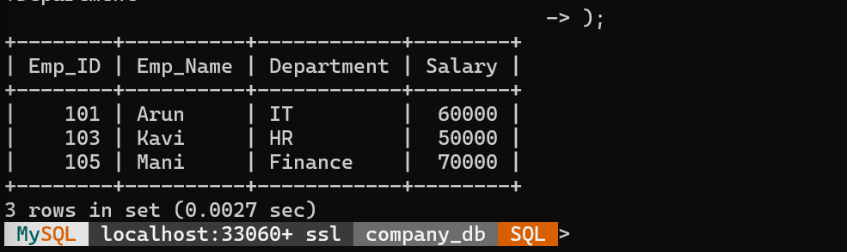
RESULT
Thus, the correlated sub-query was successfully executed to find employees whose salary is greater than the average salary of their respective departments.

5.Applying Different Types of JOIN Operations on Employee and Project Tables
AIM
To perform various SQL JOIN operations such as INNER JOIN, LEFT OUTER JOIN, RIGHT OUTER JOIN, FULL OUTER JOIN, and CROSS JOIN on Employee and Project tables to retrieve related data.
DESCRIPTION
JOIN operations are used to combine records from two or more tables based on a related column.
INNER JOIN:
Returns only the matching records from both tables.
LEFT OUTER JOIN:
Returns all records from the left table and matching records from the right table.
RIGHT OUTER JOIN:
Returns all records from the right table and matching records from the left table.
FULL OUTER JOIN:
Returns all records from both tables, including matching and non-matching records.
CROSS JOIN:
Returns the Cartesian product of two tables.

Step 1: Create Database
CREATE DATABASE company_db;

USE company_db;
Step 2: Create Employee Table
CREATE TABLE Employee(
Emp_ID INT PRIMARY KEY,
Emp_Name VARCHAR(50),
Department VARCHAR(50)
);
Step 3: Create Project Table
CREATE TABLE Project(
Project_ID INT PRIMARY KEY,
Project_Name VARCHAR(50),
Emp_ID INT,
FOREIGN KEY(Emp_ID) REFERENCES Employee(Emp_ID)
);
Step 4: Insert Records into Employee Table
INSERT INTO Employee VALUES
(101,'Arun','IT'),
(102,'Bala','HR'),
(103,'Kavi','Finance'),
(104,'Ravi','Marketing');
Step 5: Insert Records into Project Table
INSERT INTO Project VALUES
(1,'Banking System',101),
(2,'Hospital Management',102),
(3,'E-Commerce',103),
(4,'AI Project',105);
Step 6: Apply JOIN Operations
1. INNER JOIN
Display employees who are assigned to projects
SELECT
Employee.Emp_ID,
Employee.Emp_Name,
Project.Project_Name
FROM Employee
INNER JOIN Project
ON Employee.Emp_ID = Project.Emp_ID;
OUTPUT
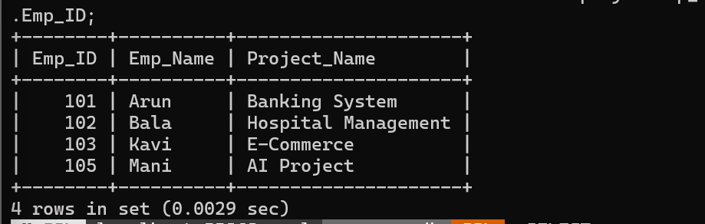
2. LEFT OUTER JOIN
Display all employees with their project details
SELECT
Employee.Emp_ID,
Employee.Emp_Name,
Project.Project_Name
FROM Employee
LEFT JOIN Project
ON Employee.Emp_ID = Project.Emp_ID;

OUTPUT
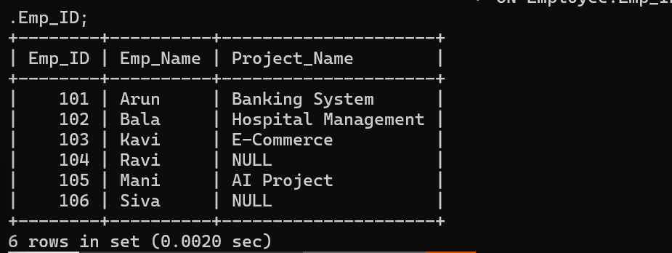
3. RIGHT OUTER JOIN
Display all projects with employee details
SELECT
Employee.Emp_ID,
Employee.Emp_Name,
Project.Project_Name
FROM Employee
RIGHT JOIN Project
ON Employee.Emp_ID = Project.Emp_ID;
OUTPUT
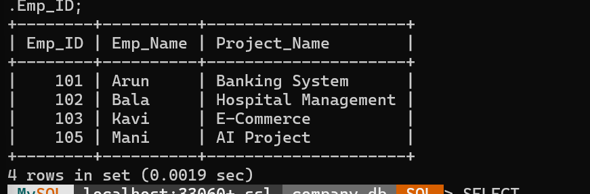
4. FULL OUTER JOIN
Display all employees and projects including unmatched records
SELECT
Employee.Emp_ID,
Employee.Emp_Name,
Project.Project_Name
FROM Employee
LEFT JOIN Project
ON Employee.Emp_ID = Project.Emp_ID

UNION

SELECT
Employee.Emp_ID,
Employee.Emp_Name,
Project.Project_Name
FROM Employee
RIGHT JOIN Project
ON Employee.Emp_ID = Project.Emp_ID;
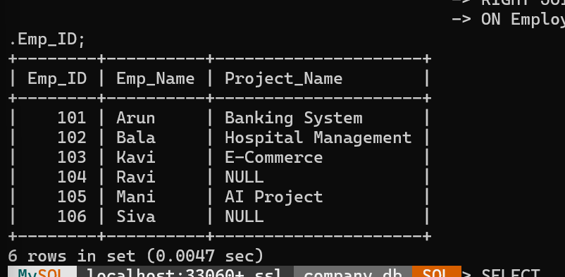
5. CROSS JOIN
Display all possible combinations of Employee and Project
SELECT
Employee.Emp_Name,
Project.Project_Name
FROM Employee
CROSS JOIN Project;
OUTPUT
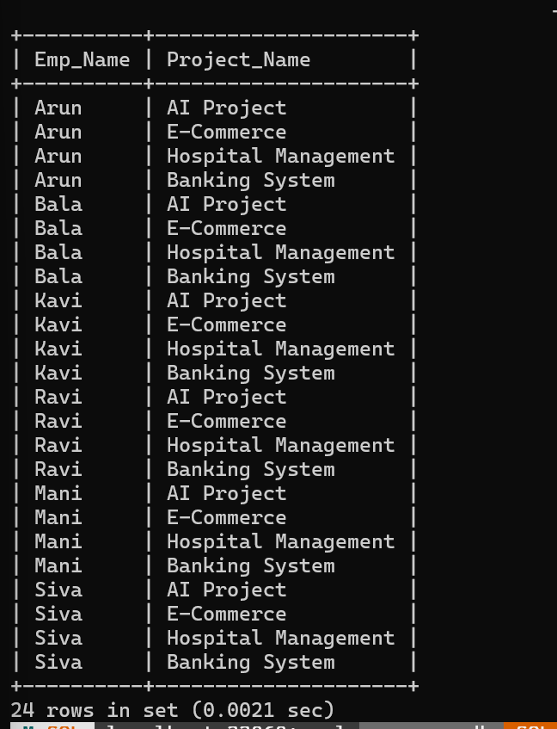
RESULT
Thus, different types of JOIN operations (INNER JOIN, LEFT OUTER JOIN, RIGHT OUTER JOIN, FULL OUTER JOIN, and CROSS JOIN) were successfully executed on Employee and Project tables to retrieve combined information.
6.Create a View DeptSalaryView that displays department name, total employees, and average salary. Write a query on this view.
AIM
To create a view DeptSalaryView that displays department name, total number of employees, and average salary of each department and execute a query on the created view.
DESCRIPTION
A view is a virtual table created from the result of an SQL query. It does not store data separately but displays data from existing tables.
The DeptSalaryView combines the Department and Employee tables using JOIN operation and uses aggregate functions like COUNT() and AVG() to calculate the total employees and average salary department-wise.
Step 1: Create Database
CREATE DATABASE department_demo;

USE department_demo;
Step 2: Create Tables
Department Table
CREATE TABLE Department(
dept_id INT PRIMARY KEY,
dept_name VARCHAR(50)
);
Employee Table
CREATE TABLE Employee(
emp_id INT PRIMARY KEY,
emp_name VARCHAR(50),
dept_id INT,
salary INT,
FOREIGN KEY(dept_id) REFERENCES Department(dept_id)
);
Step 3: Insert Records
Department Records
INSERT INTO Department VALUES
(1,'HR'),
(2,'IT'),
(3,'Finance');
Employee Records
INSERT INTO Employee VALUES
(101,'John',1,30000),
(102,'Alice',2,50000),
(103,'David',2,60000),
(104,'Sara',3,45000),
(105,'Ravi',1,35000);
Step 4: Create View DeptSalaryView
CREATE VIEW DeptSalaryView AS

SELECT
d.dept_name,
COUNT(e.emp_id) AS total_employees,
AVG(e.salary) AS average_salary

FROM Department d

JOIN Employee e
ON d.dept_id = e.dept_id

GROUP BY d.dept_name;
Step 5: Query on View
SELECT * FROM DeptSalaryView;

OUTPUT
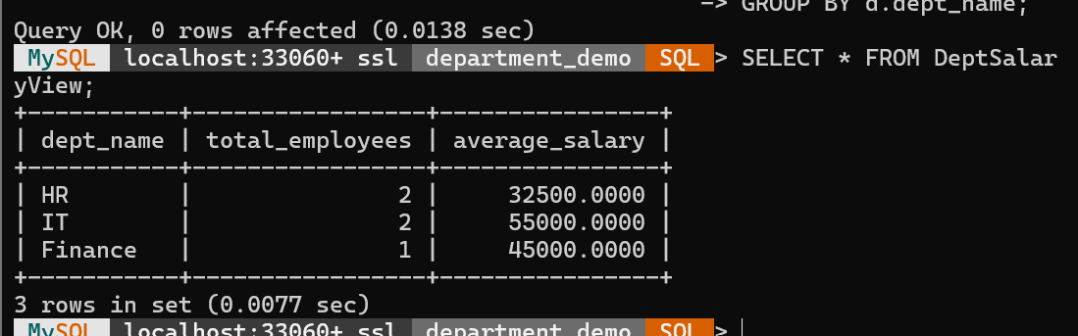
RESULT
Thus, the view DeptSalaryView was successfully created to display department name, total employees, and average salary. The query was executed successfully on the created view to retrieve department-wise salary details.

7.Constructing a Relational Algebra Expression and SQL Query to Find Students Enrolled in All Courses Offered

AIM

To construct a relational algebra expression and SQL query to retrieve the names of students who are enrolled in all the courses offered.

DESCRIPTION
Relational Algebra is a procedural query language used to perform operations on relations in a database. The Division (÷) operator is used when the query contains the keyword "all".
The equivalent SQL query uses GROUP BY and HAVING to compare the number of courses enrolled by each student with the total number of courses offered.

Step 1: Create Database
CREATE DATABASE college_db;

Step 2: Select Database
USE college_db;

Step 3: Create STUDENT Table
CREATE TABLE STUDENT(
SID INT PRIMARY KEY,
Name VARCHAR(50)
);

Step 4: Create COURSE Table
CREATE TABLE COURSE(
CID INT PRIMARY KEY,
Course_Name VARCHAR(50)
);

Step 5: Create ENROLL Table
CREATE TABLE ENROLL(
SID INT,
CID INT,
PRIMARY KEY(SID,CID),
FOREIGN KEY(SID) REFERENCES STUDENT(SID),
FOREIGN KEY(CID) REFERENCES COURSE(CID)
);

Step 6: Insert Records into STUDENT
INSERT INTO STUDENT VALUES
(101,'Arun'),
(102,'Bala'),
(103,'Kavi');

Step 7: Insert Records into COURSE
INSERT INTO COURSE VALUES
(1,'DBMS'),
(2,'Java'),
(3,'Python');

Step 8: Insert Records into ENROLL
INSERT INTO ENROLL VALUES
(101,1),
(101,2),
(101,3),
(102,1),
(102,2),
(103,1),
(103,2),
(103,3);

Step 9: Display Tables
SELECT * FROM STUDENT;

OUTPUT
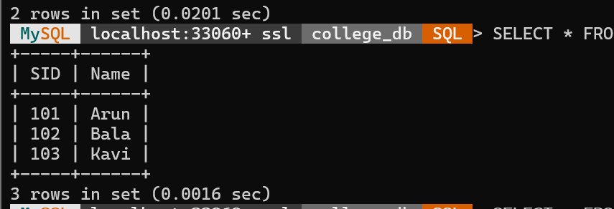
SELECT * FROM COURSE;

OUTPUT
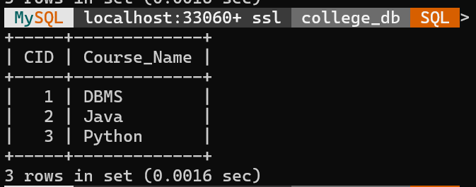
SELECT * FROM ENROLL;

OUTPUT
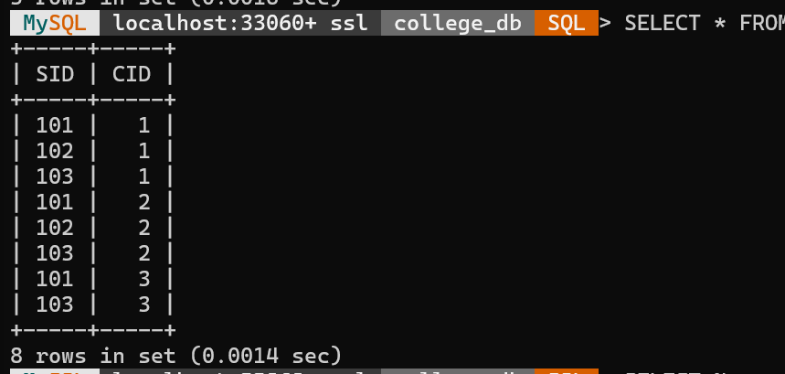

Step 10: SQL Query
SELECT NameFROM STUDENTWHERE SID IN
(
SELECT SID
FROM ENROLL
GROUP BY SID
HAVING COUNT(DISTINCT CID) =
(SELECT COUNT(*) FROM COURSE)
);

OUTPUT
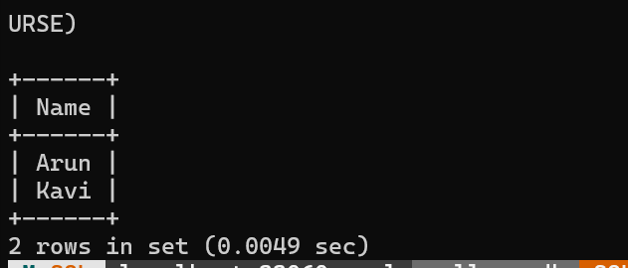

Step 11: Relational Algebra Expression
πName(STUDENT ⋈ (πSID(ENROLL ÷ πCID(COURSE))))

RESULT
Thus, the students who are enrolled in all the courses offered were successfully retrieved using the SQL query, and the equivalent relational algebra expression was constructed using the Division (÷) operator.

8.Writing SQL DML Statements (INSERT, UPDATE, DELETE) with Integrity Constraint Enforcement

AIM

To perform SQL DML operations such as INSERT, UPDATE, and DELETE on a table while enforcing integrity constraints like PRIMARY KEY, FOREIGN KEY, NOT NULL, UNIQUE, and CHECK.

DESCRIPTION
Data Manipulation Language (DML) commands are used to modify the data stored in database tables.
- INSERT – Adds new records.
- UPDATE – Modifies existing records.
- DELETE – Removes records.
Integrity constraints ensure the accuracy and consistency of data.
- PRIMARY KEY – Uniquely identifies each record.
- FOREIGN KEY – Maintains referential integrity.
- NOT NULL – Prevents NULL values.
- CHECK – Restricts values based on a condition.

Step 1: Create Database
CREATE DATABASE company_db;

Step 2: Select Database
USE company_db;

Step 3: Create Department Table
CREATE TABLE Department(
Dept_ID INT PRIMARY KEY,
Dept_Name VARCHAR(50) NOT NULL
);

Step 4: Create Employee Table
CREATE TABLE Employee(
Emp_ID INT PRIMARY KEY,
Emp_Name VARCHAR(50) NOT NULL,
Salary INT CHECK (Salary > 0),
Dept_ID INT,
FOREIGN KEY (Dept_ID) REFERENCES Department(Dept_ID)
);

Step 5: Insert Records into Department
INSERT INTO Department VALUES
(1,'IT'),
(2,'HR'),
(3,'Finance');

OUTPUT
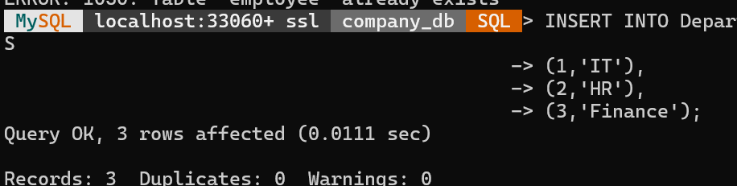

Step 6: INSERT Records into Employee
INSERT INTO Employee VALUES
(101,'Arun',60000,1),
(102,'Bala',45000,2),
(103,'Kavi',55000,3);

Step 7: Display Employee Table
SELECT * FROM Employee;

OUTPUT
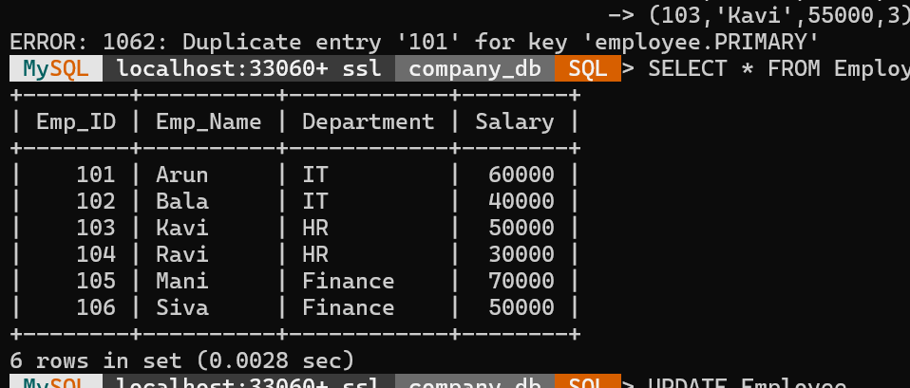

Step 8: UPDATE Statement
Increase Bala's salary to 50000.
UPDATE Employee
SET Salary = 50000
WHERE Emp_ID = 102;

OUTPUT
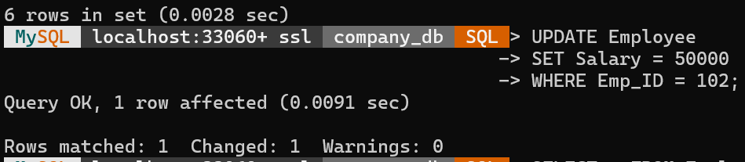Display updated table:
SELECT * FROM Employee;

OUTPUT
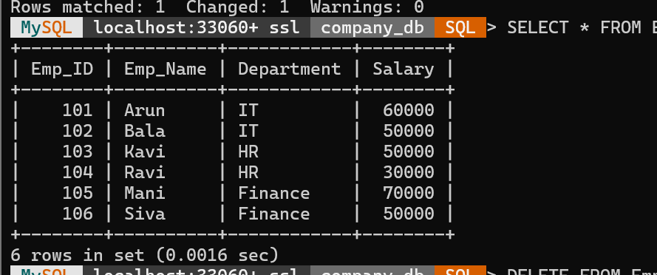

Step 9: DELETE Statement
Delete employee Kavi.
DELETE FROM Employee
WHERE Emp_ID = 103;

OUTPUT
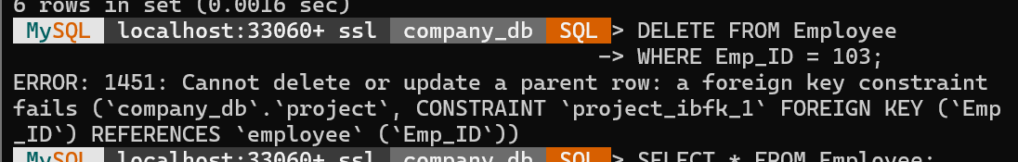
Display table after deletion:
SELECT * FROM Employee;

OUTPUT
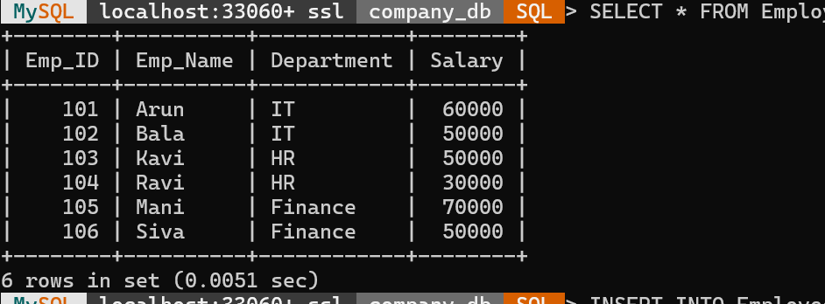

Step 10: Integrity Constraint Enforcement

Attempt to insert an employee with an invalid Department ID.
INSERT INTO Employee VALUES
(104,'Ravi',40000,5);

Attempt to insert a duplicate Employee ID.
INSERT INTO Employee VALUES
(101,'Mani',55000,1);

Attempt to insert a negative salary.
INSERT INTO Employee VALUES
(105,'Siva',-10000,1);

OUTPUT
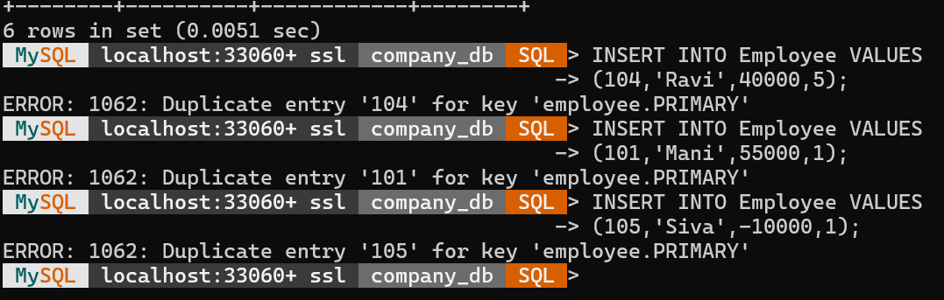

RESULT
Thus, SQL DML statements (INSERT, UPDATE, and DELETE) were successfully executed on the Employee table, and the integrity constraints (PRIMARY KEY, FOREIGN KEY, NOT NULL, and CHECK) were successfully enforced to maintain data consistency.

9.Applying Tuple Relational Calculus to Retrieve Employees Working in the 'IT' Department with Salary Greater Than 50000

AIM
To apply Tuple Relational Calculus (TRC) to retrieve the details of employees who work in the IT department and earn a salary greater than 50000.

DESCRIPTION
Tuple Relational Calculus (TRC) is a non-procedural query language in which queries are expressed using logical predicates. It specifies what data is required without describing how to retrieve it.
Assume the following relation:
EMPLOYEE(Emp_ID, Emp_Name, Department, Salary)
Where:
- Emp_ID – Employee ID
- Emp_Name – Employee Name
- Department – Department Name
- Salary – Employee Salary
The query retrieves employees whose department is 'IT' and whose salary is greater than 50000.

Step 1: Create Database
CREATE DATABASE company_db;

Step 2: Select Database
USE company_db;

Step 3: Create Employee Table
CREATE TABLE Employee(
Emp_ID INT PRIMARY KEY,
Emp_Name VARCHAR(50),
Department VARCHAR(30),
Salary INT
);

Step 4: Insert Records
INSERT INTO Employee VALUES
(101,'Arun','IT',60000),
(102,'Bala','IT',45000),
(103,'Kavi','HR',55000),
(104,'Ravi','Finance',70000),
(105,'Siva','IT',65000);

Step 5: Display Employee Table
SELECT * FROM Employee;

OUTPUT
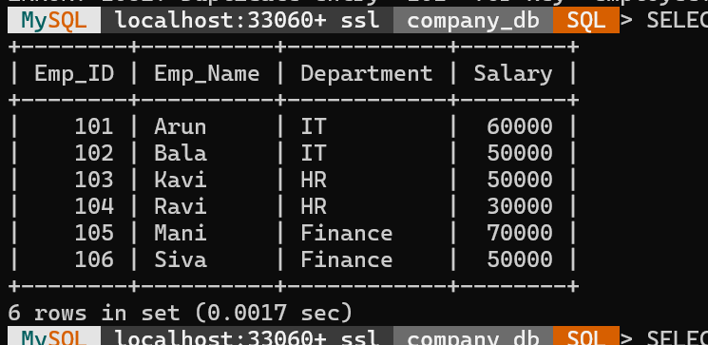

Step 6: SQL Query
SELECT *
FROM Employee
WHERE Department = 'IT'
AND Salary > 50000;

OUTPUT
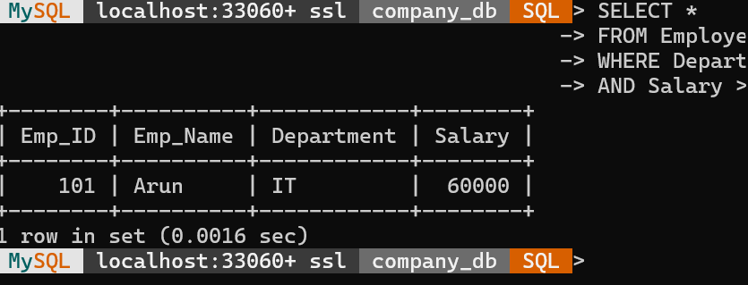

Step 7: Tuple Relational Calculus Expression
{ t | EMPLOYEE(t) ∧ t.Department = 'IT' ∧ t.Salary > 50000 }

RESULT
Thus, the employees working in the IT department and earning more than 50000 were successfully retrieved using the SQL query, and the equivalent Tuple Relational Calculus (TRC) expression was constructed successfully.

10.Design a Relational Schema for an Airline Reservation System and Write SQL Queries Using Joins, Sub-Queries, and Views

AIM
To design a relational schema for an Airline Reservation System and execute SQL queries using JOIN operations, sub-queries, and views to retrieve required information.

DESCRIPTION
An Airline Reservation System manages details about passengers, flights, airports, bookings, and payments. The database is designed using multiple relations with appropriate primary keys and foreign keys.
The main tables are:
- Passenger – Stores passenger details.
- Flight – Stores flight information.
- Airport – Stores airport details.
- Reservation – Stores booking details.
- Payment – Stores payment information.

Step 1: Create Database
CREATE DATABASE AirlineDB;

USE AirlineDB;

Step 2: Create Tables

Passenger Table
CREATE TABLE Passenger(
passenger_id INT PRIMARY KEY,
passenger_name VARCHAR(50),
age INT,
gender VARCHAR(10)
);

Airport Table
CREATE TABLE Airport(
airport_id INT PRIMARY KEY,
airport_name VARCHAR(50),
location VARCHAR(50)
);

Flight Table
CREATE TABLE Flight(
flight_id INT PRIMARY KEY,
flight_name VARCHAR(50),
source_id INT,
destination_id INT,
FOREIGN KEY(source_id) REFERENCES Airport(airport_id),
FOREIGN KEY(destination_id) REFERENCES Airport(airport_id)
);

Reservation Table
CREATE TABLE Reservation(
reservation_id INT PRIMARY KEY,
passenger_id INT,
flight_id INT,
seat_no VARCHAR(10),
FOREIGN KEY(passenger_id) REFERENCES Passenger(passenger_id),
FOREIGN KEY(flight_id) REFERENCES Flight(flight_id)
);

Payment Table
CREATE TABLE Payment(
payment_id INT PRIMARY KEY,
reservation_id INT,
amount INT,
status VARCHAR(20),
FOREIGN KEY(reservation_id) REFERENCES Reservation(reservation_id)
);

Step 3: Insert Records

Passenger Records
INSERT INTO Passenger VALUES
(1,'John',25,'Male'),
(2,'Alice',30,'Female'),
(3,'David',28,'Male');

Airport Records
INSERT INTO Airport VALUES
(101,'Chennai Airport','Chennai'),
(102,'Delhi Airport','Delhi'),
(103,'Mumbai Airport','Mumbai');

Flight Records
INSERT INTO Flight VALUES
(201,'Air India',101,102),
(202,'Indigo',102,103),
(203,'SpiceJet',101,103);

Reservation Records
INSERT INTO Reservation VALUES
(301,1,201,'A1'),
(302,2,202,'B2'),
(303,3,203,'C3');

Payment Records
INSERT INTO Payment VALUES
(401,301,5000,'Paid'),
(402,302,6000,'Paid'),
(403,303,4500,'Pending');

SQL Queries

Query 1: JOIN - Display Passenger and Flight Details
SELECT
p.passenger_name,
f.flight_name,
r.seat_no
FROM Passenger p
JOIN Reservation rON p.passenger_id = r.passenger_id
JOIN Flight fON r.flight_id = f.flight_id;

Output
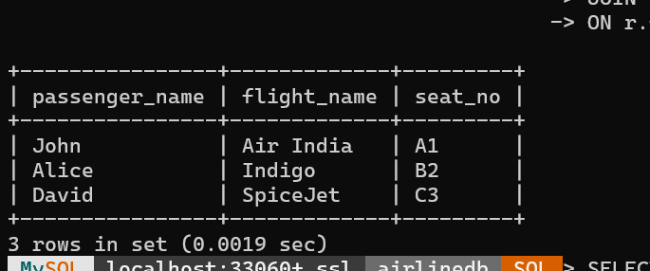

Query 2: JOIN - Display Flight Source and Destination
SELECT
f.flight_name,
a1.location AS Source,
a2.location AS Destination
FROM Flight f
JOIN Airport a1ON f.source_id = a1.airport_id
JOIN Airport a2ON f.destination_id = a2.airport_id;
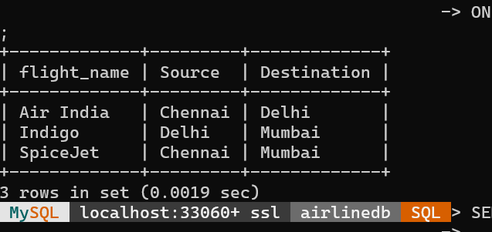

Query 3: Sub-Query - Find Passengers Who Made Payment Above Average Amount
SELECT passenger_name
FROM Passenger
WHERE passenger_id IN
(SELECT passenger_idFROM ReservationWHERE reservation_id IN
(SELECT reservation_idFROM PaymentWHERE amount >
(SELECT AVG(amount) FROM Payment)
)
);

Query 4: Sub-Query - Find Flights Having Maximum Payment
SELECT flight_name
FROM Flight
WHERE flight_id IN
(SELECT flight_idFROM ReservationWHERE reservation_id IN
(SELECT reservation_idFROM PaymentWHERE amount =
(SELECT MAX(amount) FROM Payment)
)
);

Query 5: Create View for Reservation Details
CREATE VIEW ReservationView AS
SELECT
p.passenger_name,
f.flight_name,
pay.amount,
pay.status
FROM Passenger p
JOIN Reservation rON p.passenger_id = r.passenger_id
JOIN Flight fON r.flight_id = f.flight_id
JOIN Payment payON r.reservation_id = pay.reservation_id;

Query on View
SELECT * FROM ReservationView;

OUTPUT
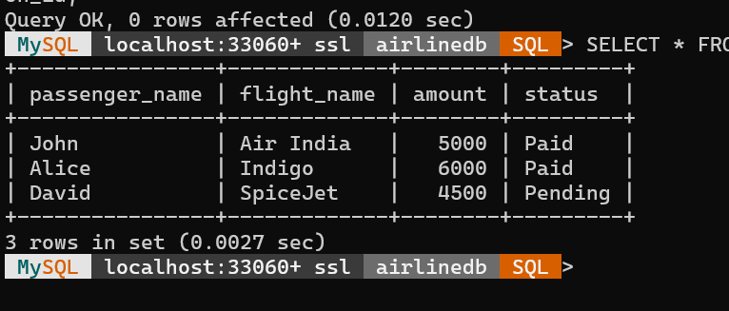

RESULT
Thus, the relational schema for the Airline Reservation System was designed successfully and SQL queries using joins, sub-queries, and views were executed to retrieve airline reservation details.

